WEEKLY UPDATE
  - Labor UPDATES:

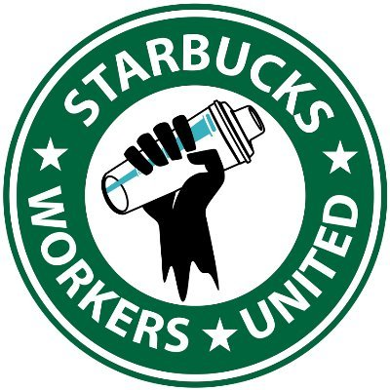  BREAKING: With over 150 locations of Starbucks now under union petition, the CEO has stepped down. Recently Starbucks has announced starting rates for baristas between $15 and $23 per hour. |  | 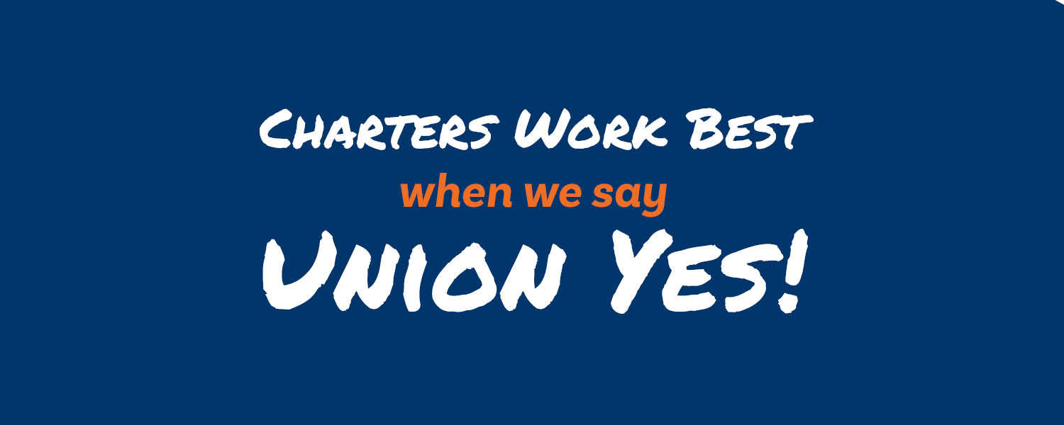  BREAKING: Educators at Menlo Park Academy charter school in Cleveland won their NLRB case and will have a union election on March 30.

LABOR UPDATES
- Starbucks workers in Overland Park, KS are ON STRIKE and are joined on the picket line by fast food workers
- Labor Board Finds Starbucks Illegally Retaliated Against Union Organizers
- Pyramid Foods in Rogersville, MO has begun to organize with the Plumbers and Pipefitters Local 178.
- In February 2022, unions won 75% of all RC petitions filed.
- ATHENS, GA – A federal investigation has found two Zaxby’s franchise restaurants in Lilburn and Grayson endangered minor-aged employees and allowed them to work outside of prescribed hours, in violation of federal child labor laws. Now they are organizing with the IWW
- Workers in Guitar Center in Seattle WA are organizing.
- Breaking: Starbucks baristas go on a ULP strike in Overland Park, KS. The workers at the store on 75th and I-35 are “…taking a stand against the company’s labor law violations…”
- The organizing of Wendy’s and the attacks from unions continue… “Billionaire chairman Nelson Peltz refuses to join the Fair Food Program, a benchmark labor & human rights program, leaving its tomato farmers vulnerable to abuse & forced labor….”
- Unions are striving to organize truckers across America and Canada – “Truckers in the United States and Canada face constant surveillance, diminishing wages, and endemic—potentially fatal—exhaustion and fatigue….”
- Over 1,000 Alabama Mineworkers have been on strike for many months, and”… mine bosses at Warrior Met have repeatedly used their connections with local courts & state police to try to break the strike. As one striking worker tells stated , they’ve got the best judges money can buy….”
- Walkout of workers of Amazon DSP occurred in MD this week, over 60 drivers walked out
- Nursing homes across the USA have now been added to the target list.
- Corporate campaigns continue against Sysco, Republic, WM, HCA, Ryder and more. Our research team has found many more.
- Next webinar will be announced shortly where we review the IWW and DSA organizing tactics

The above does not include voluntary recognition and barely covers the amount of places unions are targeting. While all of this continues, companies need to start educating employees. Employees deserve to be informed voters.

