WEEKLY UPDATE
  - Labor UPDATES:

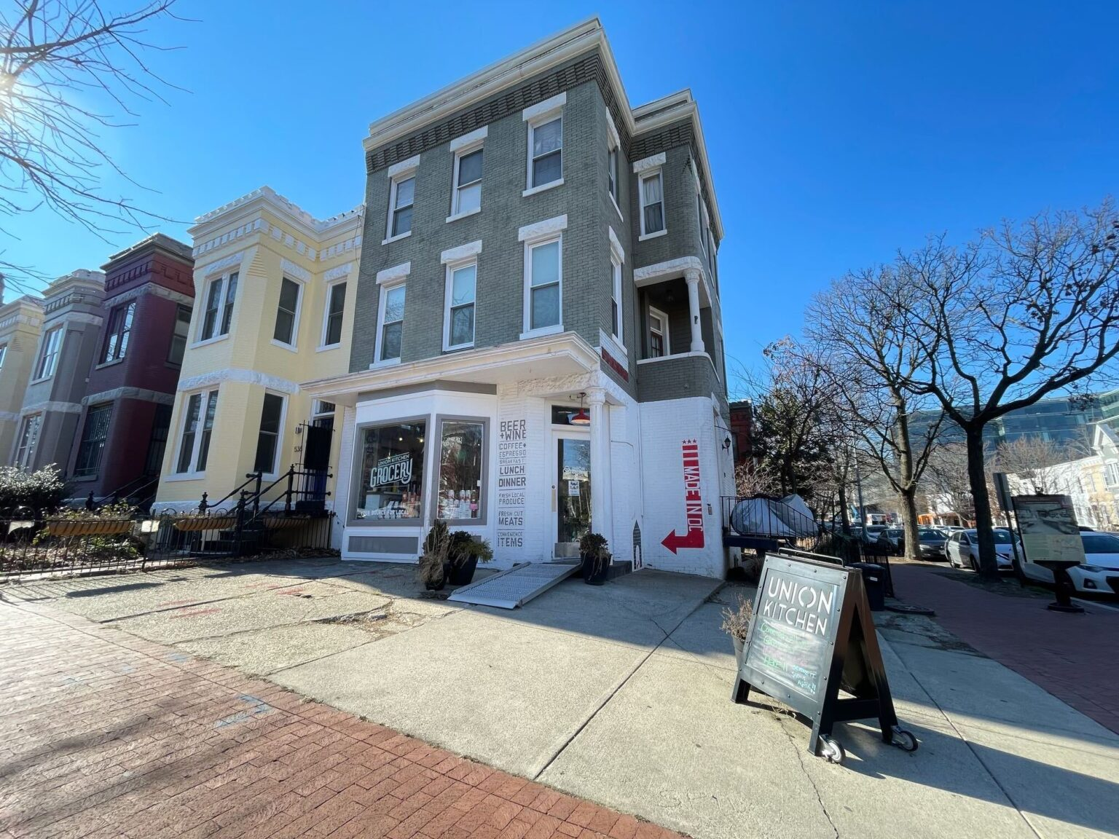  BREAKING: “Workers at Union Kitchen in DC discovered that their “progressive” company was stealing their tips — up to $150 per paycheck. When employees demanded transparency, management instead removed the option for customers to tip. Now Union Kitchen workers are unionizing at 6 locations.” |  | 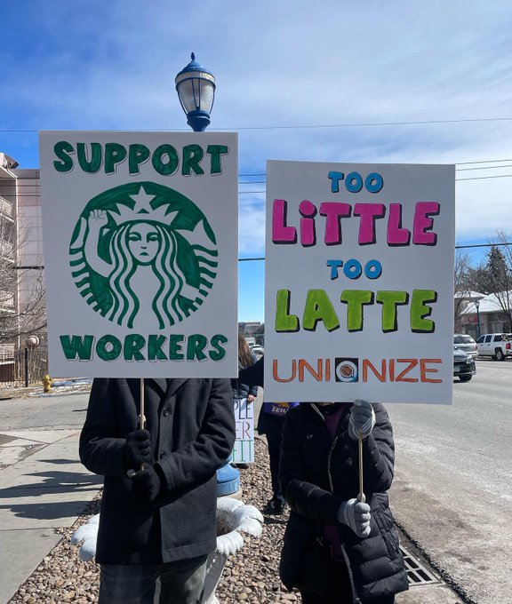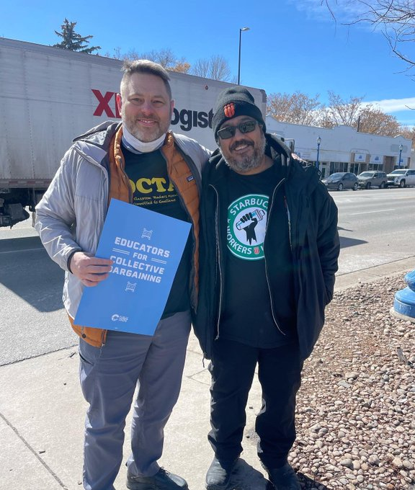  BREAKING: Starbucks workers are ON STRIKE in Denver, CO against the company's “union busting tactics. Despite Starbucks cutting hours, threatening livelihoods, and even spying on them…”

LABOR UPDATES
- Striking Seattle cement workers rallied outside the Japanese consulate yesterday. The teamsters are going up against the company CalPortland, owned by Japanese Taiheiyo. “Cement workers have been on strike for over 3 months to demand a fair contract.”
- UC San Diego spiked rents up to 85% on graduate students who “…get paid poverty wages and can't afford to live…. At the same time, UC chancellors each received $100K+ raises. The system is crushing grad students. Now ~50,000 of them, organized with UAW, are fighting back.”
- “Truly shocking how utterly Chobani and Fair Trade Dairy are failing farmworkers in their phony "Fair Trade Dairy" label.” Workers are being forced to sign "loyalty agreements not to denounce abuses as a condition for receiving gift cards.”
- A group of MIT faculty have written an open letter calling on colleagues to avoid attempting to persuade graduate students how to vote in the upcoming union election, or even giving the appearance of coercion.
- ATHENS, GA – A federal investigation has found two Zaxby’s franchise restaurants in Lilburn and Grayson endangered minor-aged employees and allowed them to work outside of prescribed hours, in violation of federal child labor laws. Now they are organizing with the IWW
- The recently established union at the cooperative Sri Lankan eatery, Mirisata — which represents all employees who are not member-owners — is now a formal affiliate of the IWW’s branch in Portland, Oregon.
- Wesleyan University in CT agrees to voluntary recognition
- NEW: 119 post production entertainment workers at Netflix, Paramount, Disney, Warner, and NBC are seeking to unionize with the CWA
- 3) 350 hospital workers including interns, residents, and fellows at the University of Vermont Medical Center are seeking to unionize with the SEIU
- Over 1,000 Alabama Mineworkers have been on strike for many months, and”… mine bosses at Warrior Met have repeatedly used their connections with local courts & state police to try to break the strike. As one striking worker tells stated , they’ve got the best judges money can buy….”
- NEW: Farmworkers are calling for a national boycott on Wendy’s. “Wendy’s billionaire chairman Nelson Peltz refuses to join the Fair Food Program, a benchmark labor & human rights program. Instead, the fast food giant leaves its tomato farmers vulnerable to abuse & forced labor.”

